GOOGLE CAPSTONE PROJECT

FLIGHT DATA ANALYSIS

BY

ADEBUSOYE OLUWAYIMIKA ELIZABETH

28TH OF JUNE 2024

# **Introduction**

This report presents a comprehensive analysis of flight data using Power BI, focusing on various aspects of customer behavior, flight activity, and revenue trends. The analysis is based on four key datasets: Customer, Flight Activity, Loyalty History, and Calendar. The primary objectives of this report are to uncover valuable insights, identify trends, and provide actionable recommendations for stakeholders.

The analysis revealed a total of 508,808 flights. Monthly revenue amounted to $5.6 million, while total revenue reached $1.2 billion. Quarterly revenue analysis showed that the first quarter had the lowest revenue of $217.7 million, while the third quarter recorded the highest at $379.5 million. In terms of customer analysis, the airport has 14,670 active customers and 2,067 inactive customers, making a total customer base of 16,737. The gender distribution is nearly even, with 49.75% male and 50.25% female. Regarding marital status, 58.16% of customers are married, 15.04% are divorced, and 26.79% are single. The company has a moderate churn rate of 14.09%.

The primary objectives of this report are to uncover valuable insights into customer behavior and flight activity, identify trends and patterns in revenue generation, and provide actionable recommendations for stakeholders to enhance business performance. By leveraging the insights from this analysis, stakeholders can make informed decisions to optimize operations, enhance customer satisfaction, and drive revenue growth.

**Data Loading and Initial Exploration**

The initial step involved loading the Customer, Flight Activity, Loyalty History, and Calendar tables into Power BI. Each dataset was meticulously examined to verify data types, check for missing values, and understand its structure. Ensuring data integrity and accuracy was paramount to facilitate reliable analysis.

**Data Model and Relationships**

Creating a robust data model was crucial for effective analysis. Relationships between the tables were established based on appropriate fields, ensuring accurate and meaningful connections. This setup enabled seamless data integration and insights across different dimensions of the datasets.

# Key Analytical Findings

1. **Number of Flight Analysis:** A line chart was developed to illustrate the total number of flights booked each year. In 2017, there were 223,236 flights booked, while in 2018, the number increased to 285,546 flights. This represents a significant rise in flight activity, from approximately 223,000 in 2017 to nearly 286,000 in 2018, as depicted in the chart below.

**Analysis:** The analysis of the number of flights booked each year is depicted in a line chart, revealing a significant increase in flight activity from 2017 to 2018. In 2017, there were 223,236 flights booked, while in 2018, this number rose substantially to 285,546 flights. This increase, from approximately 223,000 to nearly 286,000 flights, indicates a robust growth in demand for air travel over the year. The substantial rise could be attributed to several factors, such as successful marketing campaigns, improved customer loyalty programs, or favorable economic conditions that encouraged more travel. This trend highlights the airline's expanding market presence and growing customer base, suggesting a positive outlook for future growth and the potential for further increasing flight bookings through targeted strategies and continued enhancements in service offerings.

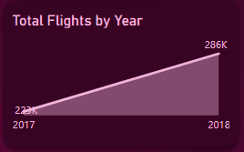

1. **Customer Segmentation:** Customers were segmented using the Customer Lifetime Value (CLV) field into high-value, medium-value, and low-value categories. The bar charts below provide clear insights into the distribution of these segments. The medium-value segment, with 8,368 customers, had the highest count, surpassing the high-value segment, which had 4,183 customers, by 100.05%. The low-value segment had a similar count to the high-value segment, with 4,186 customers.

**Analysis:** The customer segmentation analysis, based on the Customer Lifetime Value (CLV) field, categorized customers into high-value, medium-value, and low-value segments. The bar charts provided reveal that the medium-value segment has the highest count, with 8,368 customers. This segment surpasses the high-value segment, which has 4,183 customers, by a significant margin of 100.05%. The low-value segment has a similar count to the high-value segment, with 4,186 customers. This distribution indicates that most of the customer base falls into the medium-value category, suggesting a stable middle tier of customers who contribute significantly to the business. The close count between high-value and low-value segments highlights the potential for converting low-value customers into higher-value ones through targeted marketing strategies and enhanced service offerings.

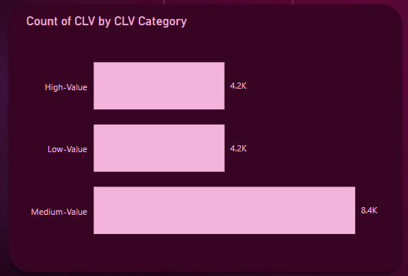

1. **Geographical Analysis:** A map visualization showcased the geographical distribution of customers across various countries and provinces, highlighting key markets and potential growth areas. In the visual below, the total flights in Canada by province are as follows: Ontario leads with 164,105 flights, followed by British Columbia with 135,178 flights, and Quebec with 99,973 flights. Alberta recorded 29,468 flights, New Brunswick had 19,960 flights, and Manitoba had 19,175 flights. Nova Scotia saw 15,514 flights, while Saskatchewan had 12,278 flights. Newfoundland recorded 7,635 flights, Yukon had 3,699 flights, and Prince Edward Island had the fewest flights at 1,823. Ontario had the highest number of flights, while Prince Edward Island had the least.

**Analysis:** The geographical analysis, represented through a map visualization, highlights the distribution of flights across various provinces in Canada, identifying key markets and potential growth areas. Ontario leads significantly with 164,105 flights, making it the primary market for flight activity. British Columbia follows with 135,178 flights, and Quebec ranks third with 99,973 flights. These three provinces collectively represent the most substantial markets. Alberta, with 29,468 flights, and New Brunswick, with 19,960 flights, along with Manitoba's 19,175 flights, form the secondary tier of markets with moderate flight activity. Nova Scotia (15,514 flights), Saskatchewan (12,278 flights), Newfoundland (7,635 flights), Yukon (3,699 flights), and Prince Edward Island (1,823 flights) exhibit lower flight activity, indicating smaller markets with potential for growth. Ontario's leading position highlights its critical importance to the airline's operations, while Prince Edward Island's low flight numbers suggest an opportunity for targeted marketing efforts to stimulate demand. This analysis underscores the need for a strategic approach to optimize service offerings and marketing efforts across diverse geographical regions, focusing on both strengthening key markets and exploring growth opportunities in less active areas.

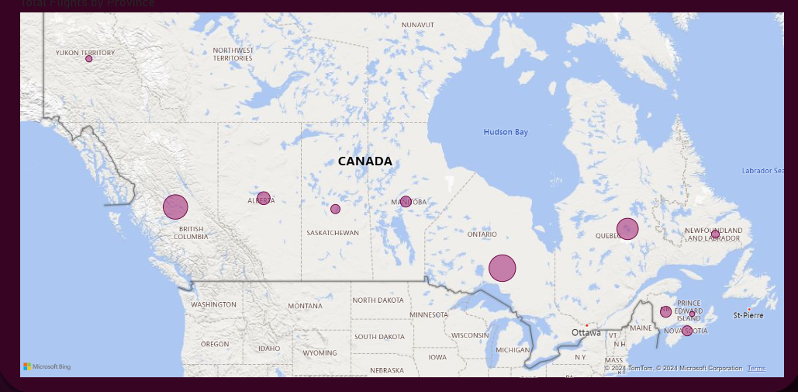

1. **Loyalty Card Analysis:** The distributions below show the number of customers based on their loyalty card status (Star, Nova, Aurora) and the average Customer Lifetime Value (CLV) for each status, providing insights into the effectiveness of the loyalty program. There are 7,637 customers with Star loyalty status, 5,671 with Nova status, and 3,429 with Aurora status. However, Aurora members have the highest average CLV at 10,672.69, followed by Nova members at 8,045.62, and Star members at 6,741.76.

**Analysis:** The loyalty card analysis reveals the distribution of customers based on their loyalty card status (Star, Nova, Aurora) and examines the average Customer Lifetime Value (CLV) for each category, offering insights into the effectiveness of the loyalty program. The data shows that the Star status has the highest number of customers, with 7,637 members. Nova status follows with 5,671 customers, and Aurora status has 3,429 customers. Despite having the smallest membership, Aurora members boast the highest average CLV at 10,672.69, indicating that they are the most valuable customers in terms of revenue generation. Nova members have an average CLV of 8,045.62, while Star members, despite being the most numerous, have the lowest average CLV at 6,741.76. This suggests that while the Star loyalty program attracts the most customers, the Aurora program is more effective in nurturing high-value customers. Therefore, the company might consider strategies to increase the membership of the Aurora program or enhance the value proposition of the Star program to boost overall customer value. This analysis highlights the need to balance the quantity and quality of customer engagement within the loyalty programs to maximize profitability.

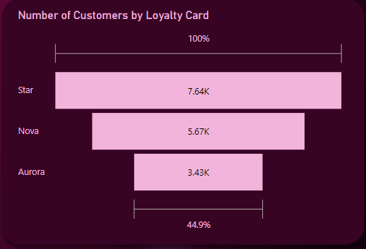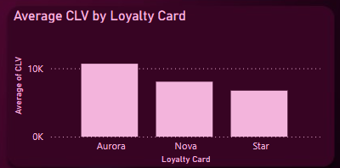

1. **Enrollment Analysis:** A line chart illustrated the trend in enrollments over the years, identifying peak periods and underlying factors. The enrollment numbers are as follows:

* 2012: 1,686 customers
* 2013: 2,397 customers
* 2014: 2,370 customers
* 2015: 2,331 customers
* 2016: 2,456 customers
* 2017: 2,487 customers
* 2018: 3,010 customers

**Analysis:** The data reveals a generally upward trend in customer enrollments from 2012 to 2018, with some fluctuations:

1. **2012 to 2013**: A significant increase of 711 enrollments, indicating a growth rate of 42.2%. This could be attributed to successful marketing campaigns or new customer acquisition strategies implemented during this period.
2. **2013 to 2014**: A slight decrease of 27 enrollments, suggesting a stabilization period after the previous year's spike.
3. **2014 to 2015**: A minor decline of 39 enrollments, indicating a plateau in growth. This might point to market saturation or the need for renewed marketing efforts.
4. **2015 to 2016**: An increase of 125 enrollments, showing a return to growth, potentially due to new initiatives or improvements in customer engagement.
5. **2016 to 2017**: A modest increase of 31 enrollments, maintaining steady growth.
6. **2017 to 2018**: A significant increase of 523 enrollments, marking the highest growth rate of 21% in the observed period. This suggests the implementation of highly effective strategies or market conditions that favored enrollments.

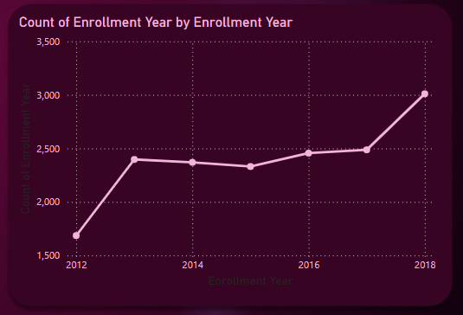

1. **Cancellation Analysis:** Visuals were developed to show the number of cancellations over the years, analyzing reasons and their impact on CLV. It was seen in the visual that as the number of cancellations grew over the years, the number of CLV grew simultaneously.

**Analysis:** The cancellation analysis involved developing visuals to display the number of cancellations over the years and examining the reasons for cancellations and their impact on Customer Lifetime Value (CLV). The visuals revealed a notable trend: as the number of cancellations increased over the years, the CLV also grew simultaneously. This simultaneous growth suggests a complex relationship between cancellations and CLV. It could imply that while the overall number of cancellations is rising, the remaining loyal customers are becoming more valuable, possibly due to enhanced loyalty programs or targeted retention efforts. Alternatively, it may indicate that higher-value customers are also canceling, which could be a concern. This trend highlights the need for a deeper investigation into the underlying reasons for cancellations and a strategic focus on improving customer retention while continuing to enhance the value provided to high-value customers.

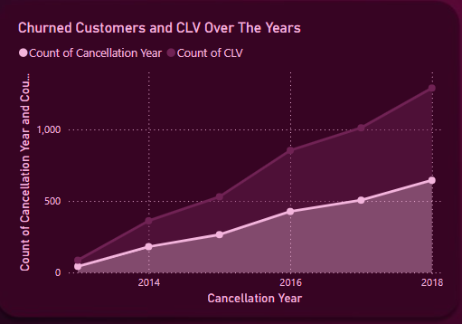

1. **Flight Distance and Points Analysis:** A scatter plot investigated the correlation between flight distance and loyalty points accumulated, revealing patterns in customer travel behavior.

**Analysis:** The scatter plot titled "Distance and Points Accumulated" demonstrates a clear positive correlation between the distance traveled by customers and the loyalty points they accumulate. The data points form an upward-sloping trend from the bottom-left to the top-right, indicating that as customers travel longer distances, they tend to accumulate more loyalty points. This correlation suggests that the loyalty program effectively rewards frequent and long-distance travelers, incentivizing more travel to earn additional points. The consistent clustering of points along the trend line reflects a stable relationship between distance and points, with no significant outliers disrupting this pattern. The upper-right section of the plot highlights the highest values for both distance and points, representing the most frequent flyers who have traveled the most and accrued the maximum points. This analysis underscores the importance of the loyalty program in encouraging repeat travel and highlights opportunities for targeted marketing efforts aimed at high-value customers who contribute significantly to the company's revenue through their frequent travel.

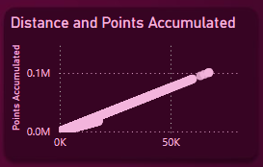

1. **Monthly Revenue Analysis:** Monthly revenue trends were calculated and visualized to offer insights into the financial performance over time. The analysis revealed that July had the highest monthly revenue at $868,664, which was 275.34% higher than January's revenue of $231,432, the lowest in the year. Overall, monthly revenue varied significantly across the year, ranging from a low of $231,432 in January to a high of $868,664 in July, indicating fluctuating demand and seasonality in the airline's financial performance.

**Analysis:** The monthly revenue analysis provides valuable insights into the airline's financial performance over time. The visualization of revenue trends reveals significant fluctuations throughout the year. July stands out with the highest monthly revenue at $868,664, which is 275.34% higher than the lowest revenue month, January, which recorded $231,432. This substantial variance indicates a strong seasonality effect, with peak demand and revenue occurring in the summer month of July, while January experiences the lowest demand. The overall monthly revenue ranges from $231,432 to $868,664, highlighting the airline's dependency on seasonal travel patterns. Understanding these trends can help in strategic planning, resource allocation, and targeted marketing efforts to optimize revenue throughout the year.

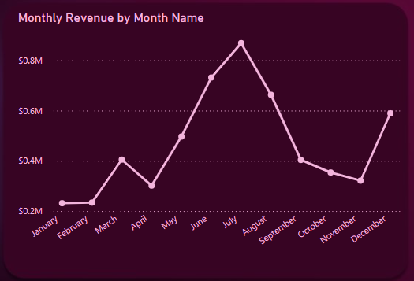

1. **Customer Demographics Analysis:** The visuals below show the analysis of customer demographics based on gender, and marital status, offering a deeper understanding of the customer base. The analysis revealed that the customer base is fairly balanced in terms of gender, with 49.75% male and 50.25% female. In terms of marital status, 58.16% of customers are married, 26.79% are single, and 15.04% are divorced. These insights into the demographics of the customer base can help tailor marketing strategies and service offerings to better meet the needs and preferences of different customer segments.

**Analysis:** The customer demographics analysis, visualized through various charts, provides a comprehensive understanding of the airline's customer base. The gender distribution is nearly balanced, with 49.75% male and 50.25% female customers, indicating no significant gender disparity. Marital status analysis shows that a majority, 58.16%, are married, while 26.79% are single, and 15.04% are divorced. This demographic breakdown suggests that marketing strategies and service offerings can be tailored to meet the needs and preferences of these distinct segments. For instance, promotional campaigns or loyalty programs could be designed to appeal specifically to married couples or single travelers, thereby enhancing customer engagement and satisfaction.

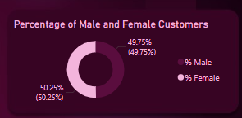

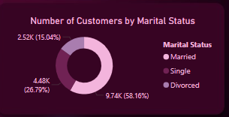

1. **Customer Enrollment Type Analysis:** Visuals were used to analyze the distribution and average Customer Lifetime Value (CLV) based on enrollment types. There are two enrollment types: 2018 Promotion and Standard. The average CLV for customers enrolled through the 2018 Promotion is 8,046.51, while the average CLV for those with Standard enrollment is 7,985.35. The higher average CLV for the 2018 Promotion can likely be attributed to the effectiveness of the 2018 advertising campaign, which successfully attracted higher-value customers.

**Analysis:** The customer enrollment type analysis, visualized through detailed charts, provides insights into the distribution and average Customer Lifetime Value (CLV) based on different enrollment types. The analysis identifies two primary enrollment types: 2018 Promotion and Standard. Customers enrolled through the 2018 Promotion have an average CLV of 8,046.51, while those with Standard enrollment have an average CLV of 7,985.35. This indicates that the 2018 Promotion has a slightly higher average CLV, which can be attributed to the effectiveness of the 2018 advertising campaign. The campaign likely attracted higher-value customers, highlighting the importance of targeted promotions and marketing efforts in increasing customer value and engagement. Understanding the impact of different enrollment types on CLV can help in designing future campaigns to attract and retain high-value customers.

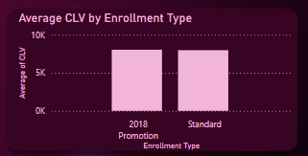

1. **Quarterly Revenue Analysis:** Quarterly revenue was calculated and visualized to highlight periods of high and low revenue. The first quarter had the lowest revenue, totaling $217,699,901, while the third quarter had the highest revenue, amounting to $379,453,469. This analysis identifies significant seasonal variations in revenue, with the third quarter outperforming the first quarter by a substantial margin.

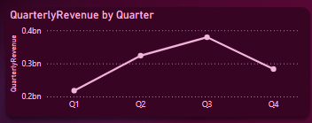

# Recommendations

Based on the comprehensive analysis of the flight data, several recommendations can be made to improve revenue, enhance customer experience, and support overall growth for the flight company:

1. **Enhance Marketing and Promotions During Low-Revenue Periods:**

- **Increase Advertising and Promotions in Q1:** Since the first quarter has the lowest revenue, targeted marketing campaigns and promotional offers can help boost sales during this period. Special discounts, loyalty points multipliers, and bundled travel packages can attract more customers.

- **Leverage High-Value Promotions:** The 2018 Promotion demonstrated success in attracting high-value customers. Similar campaigns should be replicated, focusing on key travel seasons and specific customer segments.

1. **Strengthen Loyalty Programs:**

**- Tailored Loyalty Benefits:** Given that Aurora members have the highest average CLV, consider introducing exclusive benefits and personalized offers for high-tier members. Enhance the value proposition for Nova and Star members to encourage them to increase their travel frequency and reach higher tiers.

**- Engage Medium-Value Customers:** With the medium-value segment being the largest, develop strategies to convert them into high-value customers. This could include targeted communication, personalized travel recommendations, and incremental loyalty rewards.

1. **Optimize Flight Routes and Capacity:**

**- Focus on High-Demand Provinces:** Ontario, British Columbia, and Quebec have the highest number of flights. Consider increasing flight frequency, enhancing service quality, and offering more direct routes to these key markets to capitalize on demand.

**- Expand in Underutilized Areas:** Provinces like Prince Edward Island and Yukon have the fewest flights. Assess the potential for growth in these regions through market research and pilot initiatives to increase presence and service offerings.

1. **Improve Customer Segmentation and Personalization:**

- **Demographic-Based Marketing:** Utilize the balanced gender distribution and diverse marital status data to create targeted marketing campaigns. For instance, offer family travel packages for married customers or adventure travel deals for single customers.

**- Leverage Customer Data**: Continuously analyze customer behavior and preferences to personalize communication, offers, and services. Use data-driven insights to enhance customer satisfaction and loyalty.

1. **Address Customer Churn:**

**- Churn Reduction Programs:** With a churn rate of 14.09%, it's crucial to implement retention strategies. This could include personalized re-engagement campaigns, feedback loops to understand reasons for churn, and improved customer service.

**- Monitor and Act on Feedback:** Regularly collect and analyze customer feedback to identify pain points and areas for improvement. Promptly addressing customer concerns can reduce churn and improve overall satisfaction.

1. **Maximize Revenue from Seasonal Peaks:**

- **Prepare for High-Demand Periods:** The third quarter shows the highest revenue, likely due to peak travel seasons. Ensure optimal flight scheduling, pricing strategies, and resource allocation to handle increased demand efficiently.

**- Dynamic Pricing Strategies:** Implement dynamic pricing models that adjust fares based on demand fluctuations. This can help maximize revenue during peak seasons while maintaining competitive pricing during off-peak periods.

1. **Expand Customer Base Through New Enrollments:**

- **Promote Enrollment Campaigns:** Given the success of past enrollment campaigns, continue to invest in promotional activities that encourage new customer sign-ups. Highlight the benefits of membership and the value of loyalty programs.

- **Analyze Enrollment Trends:** The analysis showed peak enrollment periods. Understand the factors driving these peaks and replicate successful strategies to sustain enrollment growth.